Vortex IoT Starter Kit

User Guide

Table of Contents

1. Introduction 3
2. Hardware Setup 4
3. Raspberry Pi Micro SD Setup 5
4. Raspberry Pi Network Configuration 5
.4.1 Default 5
.4.2 Static IP Address 5
.4.3 Wireless Config 5
5. Connecting an SSH and FTP Client 6
.5.1 Connect to Raspberry Pi with SFTP 6
.5.2 Connect to Raspberry Pi with SSH 6
6. Test Grove Pi Sensors 7
7. Setting Vortex Environment Variables 7
8. Vortex Web Server 8
9. Freeboard HTTP Server 9
10. Vortex OpenSplice 12
.10.1 Light Sensor Publisher and Freeboard 12
.10.2 Rotary Angle Sensor and Freeboard 14
.10.3 Application Monitor 15
.10.4 LED Subscriber 16
11. Modifying the VortexGrove Example 17
.11.1 C++ Files 17
.11.2 Interface Definition Language (IDL) file 17
.11.3 Vortex Web IDL2J Compiler 18
12. PrismTech Contacts 19
13. Notices 19

Introduction

The Vortex IoT Starter Kit contains a ready-to-go example of an end to end Data Distribution Service (DDS). It is comprised of a Grove Pi with several sensors directly connected to the I2C port of a Raspberry Pi. The Raspberry Pi hosts Vortex Web and Vortex OpenSplice which use this I2C port as an I/O to the Grove Pi, which in turn controls the sensors.

Vortex OpenSplice is an advanced and proven data-centric solution that enables seamless, timely, scalable and dependable distributed data sharing from Embedded and Mobile Devices to the Enterprise and the Cloud.

Vortex Web is a JavaScript implementation of the DDS APIs to enable HTML5 / Web browser applications to send and receive data to and from the Vortex DDS data backbone. This example integrates Vortex Web and Freeboard, an open source interactive dashboard, to visualise sensor information on the DDS. All of this is pre-installed on the accompanying Raspberry Pi image file.

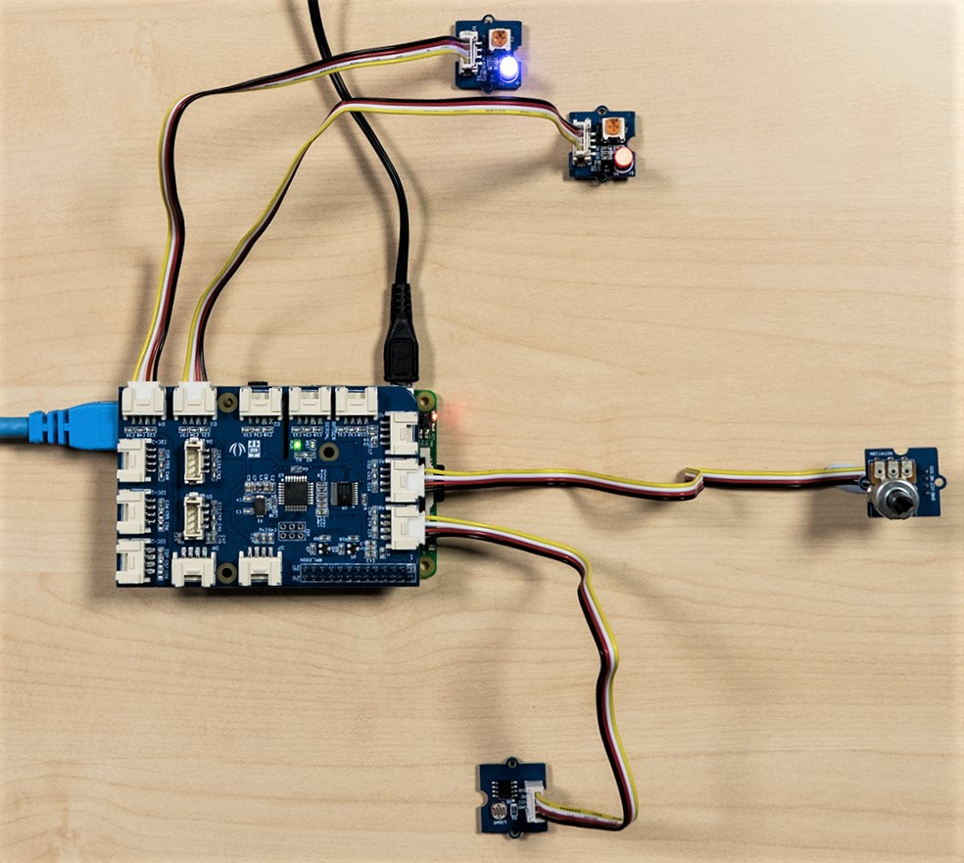

Hardware Setup

The Raspberry Pi and Grove Pi have been pre-assembled with an enclosure, accompanied by various Grove Pi Sensors.

This example uses the Red and Blue Grove LED’s, the Rotary Angle Sensor and the Light Sensor. Connected as shown in the previous image to the following ports:
- Blue LED – Port D4
- Red LED – Port D3
- Rotary Angle Sensor – Port A1
- Light Sensor – Port A0
Raspberry Pi Login:
- Username: root
- Password: system
- Username: pi
- Password: raspberry
Desktop requirements:
- Network connectivity to the Raspberry Pi.
- Browser - Google Chrome preferred.
- Vortex Web - If you wish to modify the example code later.
- SSH client - To execute the example from the Desktop (avoids having to work directly on the Raspberry Pi).

Raspberry Pi Micro SD Setup

Depending on platform there are lots of ways to do this, all are easy and detailed instructions can be found here http://elinux.org/RPi_Easy_SD_Card_Setup.

Use the VortexGrove.img file provided by PrismTech with the following services already configured for use:
- Raspbian Jessie
- Vortex OpenSplice
- Vortex Web
- Freeboard HTTP Server
- Grove Pi
Insert the microSD card into the Raspberry Pi and power on.

Raspberry Pi Network Configuration

Default

The Raspberry Pi is currently configured for DHCP over Ethernet, however to discover it’s address you will have to connect a mouse, keyboard and monitor to the Raspberry Pi.

*Note: The Raspberry Pi must be powered down before attaching the HDMI.

Once the Raspberry Pi is connected to a monitor and the Ethernet, power it on. Open a terminal and type “ifconfig”, this will give you the IP address the DHCP server has assigned. Assuming your Desktop PC is on the same network you will now be able to SSH into the Raspberry Pi as described in the next section.

It is also possible to run these examples directly from the Raspberry Pi using a monitor, keyboard and mouse. In the following sections enter the commands into a local terminal, and use the loopback address for the Freeboard dashboard in the Raspberry Pi’s web browser.

Static IP Address
Alternatively, you can now statically address your Raspberry Pi by following this guide: http://elinux.org/Configuring_a_Static_IP_address_on_your_Raspberry_Pi

Wireless Config
If you want to connect wirelessly follow this guide: https://www.raspberrypi.org/documentation/configuration/wireless/wireless-cli.md

Connecting an SSH and FTP Client

In order to run the examples remotely and modify any of the files on the Raspberry Pi you need an SSH and FTP client. Putty and FileZilla are both cross platform freeware.

Connect to Raspberry Pi with SFTP

The Raspberry Pi will only allow secure file transfer protocol for connection.
- Host: sftp://(IP Address)
- Username: root
- Password: system
- Port: 22
This is the easiest way to see and understand the Raspberry Pi’s folder structure. The examples are located in: /home/pi/Documents/PrismTech/VortexGrove

Connect to Raspberry Pi with SSH

For the purpose of the example six active SSH terminals between the Desktop and Raspberry Pi are needed.
- Command line based: “ssh root@(IP Address)”
- Password: system
- SSH client based: Host: (IP Address)
- Login: root
- Password: system
Do this for all six SSH terminals, creating six active sessions.

Test Grove Pi Sensors

For the example the following sensors need to be connected:
- Blue LED – Port D4
- Red LED – Port D3
- Rotary Angle Sensor – Port A1
- Light Sensor – Port A0
Test the LED’s by running the Grove Pi Python script:
- python /home/pi/Documents/PrismTech/GrovePi/Software/Python/grove_led_blink.py
Modify the above script and change the port number from D4 to D3 “led = 3” and test the next LED. It’s not easy to tell the anode from the cathode for the LED’s, so if it doesn’t work try it the other way around.

Test the Rotary Angle (Potentiometer) and light sensors:
- python /home/pi/Documents/PrismTech/GrovePi/Software/Python/grove_rotary_angle_sensor.py
- python /home/pi/Documents/PrismTech/GrovePi/Software/Python/grove_light_sensor.py

Setting Vortex Environment Variables

In order to run Vortex OpenSplice, certain environmental variables must be set. There is a file in the Vortex OpenSplice distribution that sets these automatically. In each of the 6 SSH terminals run this command:
- source /home/pi/Documents/PrismTech/VortexOpenSplice-6.7.1p3/HDE/armv7l.linux/release.com
*Note: You’ll have to repeatedly enter this file path, and the “.” (special characters) need to be escaped in file paths to avoid errors. The easiest way to do this is to type the first few letters of each path, then press TAB to auto-complete the entry.

Once completed, you will see this in your console:
- <<< Vortex OpenSplice HDE Release 6.7.1p3 For armv7l.linux, Date xxxx-xx-xx >>>
Make sure this has been successful by typing “ospl”, you should see a Usage screen with available command line parameters:

Usage:
ospl -h
ospl -v
ospl [-e] [-f] start [URI]
ospl [-e] [[-d <domain> | -a] stop [URI]]
ospl [-e] list
ospl [-e] status [URI]

Vortex Web Server

The Vortex Web Server will be the link between the Vortex OpenSplice Distributed Data Service which publishes sensor information, and a HTTP Server which will host the Freeboard interface to view this sensor information.

Vortex Web is a Java application and as such requires a java export of the Interface Definition Language (IDL) file, you can generate your own by following instructions in section 11. Modifying the VortexGrove Example, if you later modify the example IDL file.

For this example, the relevant java files have already been generated. In one of the SSH terminals enter:
- cd /home/pi/Documents/PrismTech/VortexWeb-1.2.4p1/bin
- ./start
-Ddds.types.classpath="/home/pi/Documents/PrismTech/VortexGrove/VortexGrove.jar"
The following should be output to the terminal:

Play server process ID is 1473
14:59:11.734 [main] INFO play - Application started (Prod)
14:59:12.202 [main] INFO play - Listening for HTTP on /0:0:0:0:0:0:0:0:9000

Vortex Web is running and ready.

Freeboard HTTP Server

In another SSH terminal enter:

- cd /home/pi/Documents/PrismTech/Freeboard/
- python -m SimpleHTTPServer 8000

Freeboard should now be live, check this by browsing from a Desktop web browser (Google Chrome preferred).
- http://x.x.x.x:8000#source=dashboard.json
The server will output:

- Serving HTTP on 0.0.0.0 port 8000 ...

You should see this displayed in your browser:

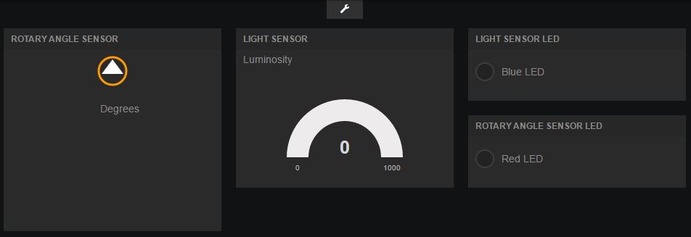

The freeboard application subscribes to Topic data published into DDS. The Data Source timestamps update on the Freeboard display when DDS samples are being successfully received (after starting a Vortex OpenSplice publishing application).
Note that the Freeboard dashboard needs to be configured to read Topic data from the IP Address of the Raspberry Pi. Click the spanner icon to display freeboard settings as shown.

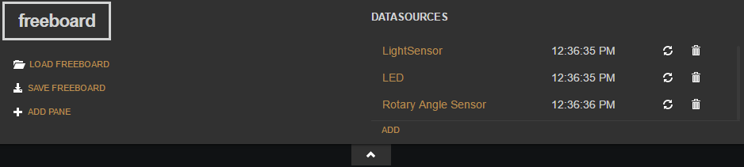

For both Data Sources, modify the below URL to the Raspberry Pi’s IP Address.

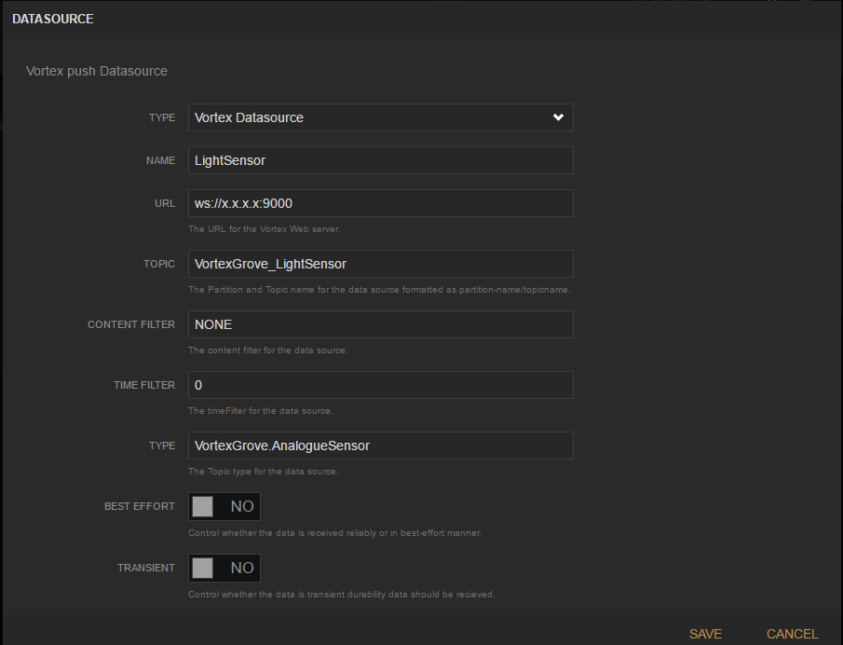

Save the change for each Data Source, then save the modified dashboard.json.

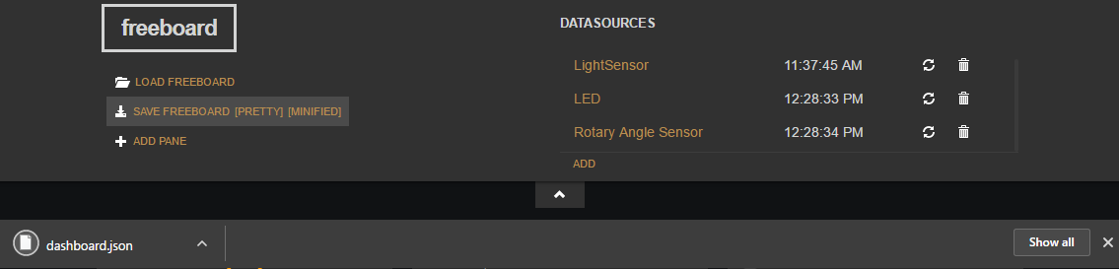

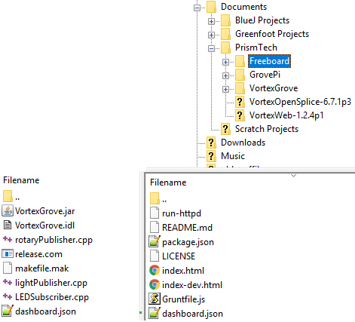
This JSON file contains all changes you make to your freeboard
interface, to make it the new default it needs to be replaced on
the Raspberry Pi. To do this use your FTP client to transfer the
updated dashboard.json into the
/home/pi/Documents/PrismTech/Freeboard directory and
overwrite the existing one. If you make changes to the JSON
and transfer as shown, but these changes are not shown in the
browser it is possible that the browser has cached an old
webpage. Go to Settings -> History -> Clear Browsing Data
-> Clear cached images and files.

For Freeboard to ‘see’ data on DDS it must create a Data Reader for each Topic used, to do this it registers with the Vortex Web Server, if this has been successful the communication between Vortex Web/Freeboard and Vortex OpenSplice will be output to the terminal, it will look similar to this:

[application-akka.actor.default-dispatcher-7] INFO cafe.ddsi.entities - Created local Reader [007f0101.00001328.00000000 00000407] on Topic 'VortexGrove_LightSensor'

[application-akka.actor.default-dispatcher-7] INFO cafe.ddsi.disc - New match between remote Writer [24ed36b1.000005b2.00000001 00000202] and local Reader [007f0101.00001328.00000000 00000407] on Topic VortexGrove_LightSensor

[application-akka.actor.default-dispatcher-2] INFO cafe.ddsi.entities - Created local Reader [007f0101.00001328.00000000 00000507] on Topic 'VortexGrove_LED'

[application-akka.actor.default-dispatcher-2] INFO cafe.ddsi.disc - New match between remote Writer [0ddcc70b.00000350.00000001 00000502] and local Reader [007f0101.00001328.00000000 00000507] on Topic VortexGrove_LED

[application-akka.actor.default-dispatcher-3] INFO cafe.ddsi.entities - Created local Reader [007f0101.00001328.00000000 00000607] on Topic 'VortexGrove_RotarySensor'

[application-akka.actor.default-dispatcher-3] INFO cafe.ddsi.disc - New match between remote Writer [677f45d8.00000446.00000001 00000202] and local Reader [007f0101.00001328.00000000 00000607] on Topic VortexGrove_RotarySensor

The discovery process can take a few seconds so there may be a delay between a new participant (new OpenSplice process) being launched and Freeboard showing an update.

Vortex OpenSplice

There are four OpenSplice applications to run in this example, the deployment configuration for any Vortex OpenSplice deployment is defined within the ospl.xml configuration file located in $OSPL_HOME/etc/config, this file is defined by the $OSPL_URI variable on the Raspberry Pi.

The default ospl.xml selected defines the following parameters, which are perfect for this example:
- Single Process Deployment – Each application runs in its own process.
- DDSI2 Networking – the standardised DDS wire protocol.
- Multicast communication – Used for discovery of other Vortex processes.

Light Sensor Publisher and Freeboard

First start the Light Sensor Publisher in an unused SSH terminal to confirm connectivity between
Light Sensor -> Grove Pi <-> Raspberry Pi <-> Light Publisher Application <-> Vortex OpenSplice DDS <-> Vortex Web <-> Freeboard HTTP Server -> Browser

Start the Light Publisher by entering the following:
- cd /home/pi/Documents/PrismTech/VortexGrove
- ./lightPublisher
The default number of cycles the application does is 10,000 but can be specified as a parameter by typing:
- ./lightPublisher [number of cycles]
You should see the following output in your terminal as it sends these samples:

=== [lightPublisher] Participant Created
=== [lightPublisher] Topic VortexGrove_LightSensor Created
=== [lightPublisher] Publisher and DataWriter Created
=== [lightPublisher] Grove Pi initialised
=== [lightPublisher] Sending Light Sample No.[0] Data: [753]
=== [lightPublisher] Sending Light Sample No.[1] Data: [757]

This application will run until the process is manually stopped with a CTRL-C interrupt. When you start this application, it will read the sensor data every second and publish it to DDS. More information about how this happens can be read in the source file lightPublisher.cpp. Vortex Web will automatically discover this new DDS participant and recognise the Topic type being published (by a Data Writer) matches that of the Freeboard Data Reader:

[Old I/O datagram worker ([id: 0xa435aba5, 0.0.0.0/0.0.0.0:7400])] INFO cafe.ddsi.disc - Discovered a remote Participant: [5ccddc33.00000345.00000001 PARTICIP]

[Old I/O datagram worker ([id: 0xa435aba5, 0.0.0.0/0.0.0.0:7400])] INFO cafe.ddsi.disc - New match between remote Writer [5ccddc33.00000345.00000001 00000202] and local Reader [007f0101.00000d7e.00000000 00000307] on Topic VortexGrove_LightSensor

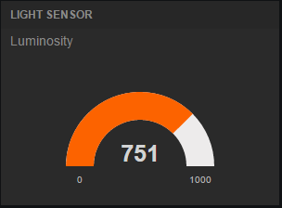
As the light publisher puts data into DDS, Freeboard will update the corresponding data source at the same rate it is published.

Rotary Angle Sensor and Freeboard

Data from the rotary angle sensor (Potentiometer) is sent in the same way as the light sensor, in an unused SSH terminal enter:
- cd /home/pi/Documents/PrismTech/VortexGrove
- ./rotaryPublisher
The default number of cycles the application does is 10,000 but can be specified as a parameter by typing:
- ./rotaryPublisher [number of cycles]
You should see the following output in your terminal as it sends these samples:

=== [rotaryPublisher] Cycles: 10,000, CTRL - C to exit.
=== [rotaryPublisher] Participant Created
=== [rotaryPublisher] Topic VortexGrove_RotarySensor Created
=== [rotaryPublisher] Publisher and DataWriter Created
=== [rotaryPublisher] Grove Pi initialised
=== [rotaryPublisher] Sending Sample No.[0]=== [rotaryPublisher] Data: 752
=== [rotaryPublisher] Sending Sample No.[1]=== [rotaryPublisher] Data: 752

Vortex Web and Freeboard will respond in the same way as it did for the lightPublisher:

[Old I/O datagram worker ([id: 0x2c8095fe, 0.0.0.0/0.0.0.0:7400])] INFO cafe.ddsi.disc - Discovered a remote Participant: [14169f80.00000589.00000001 PARTICIP]
[Old I/O datagram worker ([id: 0x2c8095fe, 0.0.0.0/0.0.0.0:7400])] INFO cafe.ddsi.disc - New match between remote Writer [14169f80.00000589.00000001 00000202] and local Reader [007f0101.00001328.00000000 00000607] on Topic VortexGrove_RotarySensor

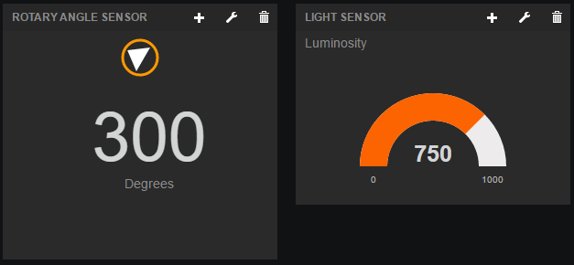

Application Monitor

The next application to start is the applicationMonitor, in an unused SSH terminal enter:
- cd /home/pi/Documents/PrismTech/VortexGrove
- ./applicationMonitor
This application creates a DDS Subscriber, with two DDS Data Readers. A Data Reader is specific to a DDS Topic; therefore, we need one for each Topic (both sensors use a unique Topic). The application also creates a DDS Publisher in order to send samples of the LED topic. In the applicationMonitor.cpp there are two hardcoded parameters, maxDegree = 200 and maxLux = 700. Each value received is compared to its maximum, when this condition is met a sample is published into DDS for the Topic LED with a state of ON. A separate application which controls the LED’s will be started later, however Freeboard is also subscribed to the LED topic and so will see the published state.

=== [lightPublisher] Sending Sample No.[0] Data: [753]
=== [lightPublisher] Sending Sample No.[1] Data: [755]

=== [applicationMonitor] Lux: [753]
=== [applicationMonitor] Lux exceeded.
=== [applicationMonitor] Lux: [755]
=== [applicationMonitor] Lux exceeded.

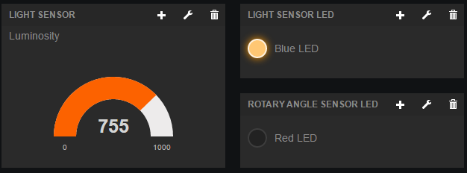

LED Subscriber

The final application of this example controls the state of the red and blue LED’s, in the last unused SSH terminal enter:
- cd /home/pi/Documents/PrismTech/VortexGrove
- ./LEDSubscriber
Output from LEDSubscriber:

=== [LEDSubscriber] Participant Created
=== [LEDSubscriber] Topic VortexGrove_LED Created
=== [LEDSubscriber] Grove Pi initialised
=== [LEDSubscriber] Serving Light Sensor LED on D4
=== [LEDSubscriber] Serving Rotary Sensor LED on D3
=== [LEDSubscriber] Waiting for samples...

Now that all applications are running, when the light level exceeds its maximum the blue LED will switch ON, and when the rotary angle exceeds its maximum the red LED will switch ON. This will be reflected in the Freeboard interface as shown:

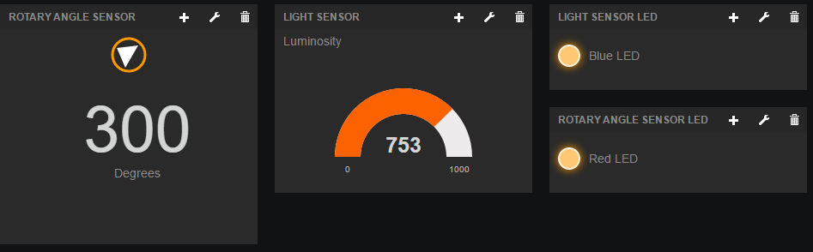

*Note: It’s not uncommon to see the following error to be output in the terminal, it’s caused by repeated read write commands between the Raspberry Pi and Grove Pi, however it’s harmless, won’t affect the program and only occurs once in every 500 read / writes or so:
- ERROR: Unable to write block to GrovePI. Input/output error

Modifying the VortexGrove Example

C++ Files

The best way to understand how Vortex OpenSplice and this example works is to examine the source code. Use the FTP client to transfer and open the following files on a Desktop machine (they can also be opened locally using a file editor such as nano):
- /home/pi/Documents/PrismTech/VortexGrove/applicationMonitor.cpp
- /home/pi/Documents/PrismTech/VortexGrove/LEDSubscriber.cpp
- /home/pi/Documents/PrismTech/VortexGrove/lightPublisher.cpp
- /home/pi/Documents/PrismTech/VortexGrove/rotaryPublisher.cpp
- /home/pi/Documents/PrismTech/VortexGrove/makefile
- /home/pi/Documents/PrismTech/GrovePi/Software/C/PTModified/grovepi.h
The source code is well commented and easy to follow, it can be used to experiment and make changes, then transfer these files back to the Raspberry Pi. Once on the Pi, use the makefile to compile them by entering:

- cd /home/pi/Documents/PrismTech/VortexGrove
- make -f makefile

This will recompile ‘new or changed’ files, to force a complete recompile (sometimes necessary if only small changes are made):

- make -B -f makefile

The makefile contains all the necessary library links for an OpenSplice application, as well as a link to grovepi.h, this is the Grove Pi’s C API which provides functions to send commands between the Raspberry Pi and the Grove Pi over the I2C port.

Interface Definition Language (IDL) file

The base file for any Vortex OpenSplice application is the IDL file, this is the template for all Topic Data Types that can be used in an OpenSplice application. The VortexGrove.idl is shown below.
This example uses three Topics (explained more in the source code), two of the Topics are of Data Type VortexGrove::AnalogueSensor and one is of type VortexGrove::LED.
module VortexGrove {

struct AnalogueSensor {
short id;
float rValue;
float value;
};
#pragma keylist AnalogueSensor id

struct LED {
short id;
boolean on;
};
#pragma keylist LED id
};

To create a new Topic, with a different structure than the three Topics used in the example, it must be defined in this file.

The makefile will use this file to generate all relevant links between the a newly defined Topic Data Type and Vortex OpenSplice. However, Vortex Web also uses this file to interact with DDS and so requires Java classes to be generated in order to work.

Vortex Web IDL2J Compiler

The Vortex Web Java files required must be generated on a Desktop machine. This means that the JVM or JDK used to generate the files must be the same or lower version that the Java version on the Raspberry Pi, which is currently:

openjdk version "1.8.0_40-internal"
OpenJDK Runtime Environment (build 1.8.0_40-internal-b04)
OpenJDK Zero VM (build 25.40-b08, interpreted mode)

Ensure Vortex Web is installed and licensed, in an Administrator command prompt (windows) or as super user in terminal (Unix) do the following:
- cd <location of VortexGrove.idl file>
- java -classpath "<location of VortexWeb>\lib\server\idl2j.jar" com.prismtech.cafe.idl2j.Compiler VortexGrove.idl
- javac -classpath "<location of VortexWeb>\lib\server\cafe.jar" VortexGrove\*.java
- jar cvf VortexGrove.jar VortexGrove\*.class
*Note: Be careful not to miss or add extra spaces.

Once completed there will be additional files in the same directory as VortexGrove.idl shown here on the left, transfer these along with the modified IDL file into the VortexGrove directory on the Raspberry Pi.
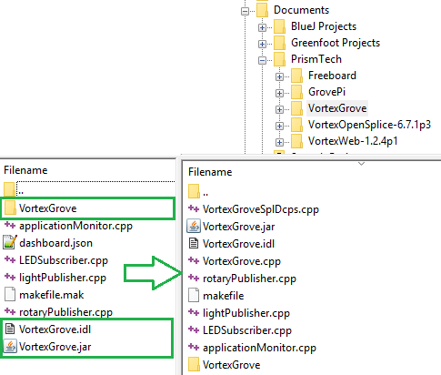

PrismTech Contacts

USA Headquarters
PrismTech Corp
400 TradeCenter
Woburn, MA 01801
USA
Tel: +1-781-569-5819

European Headquarters
PrismTech ltd
PrismTech House, 5th Avenue Business Park,
Gateshead, Tyne and Wear, NE11 0NG
United Kingdom
Tel: +44-(0)191-4979900

PrismTech France
28 rue Jean Rostand,
91400 Orsay
France
Tel: +33-(1)69-01 5354

Web: www.prismtech.com
Email: info@prismtech.com

Notices
© 2017 PrismTech Corporation. All rights reserved. This document may be reproduced in whole but not in part. The information contained in this document is subject to change without notice and is made available in good faith without liability on the part of PrismTech Corporation. All trademarks acknowledged.

